**Services:**

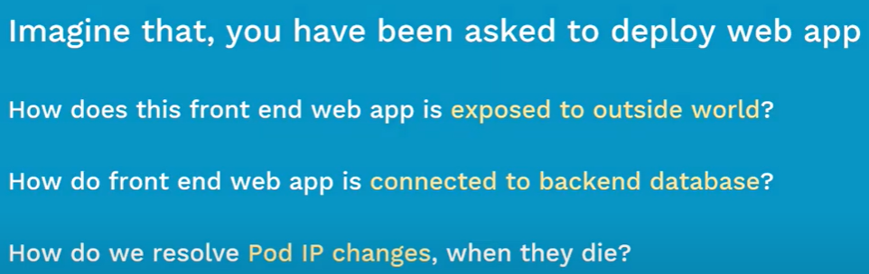

* PODs are ephemeral. It gets created and dies. To make the pod running all the time, we need to have replication controller or replicasets.
* So, when POD dies, it gets created with new IP.

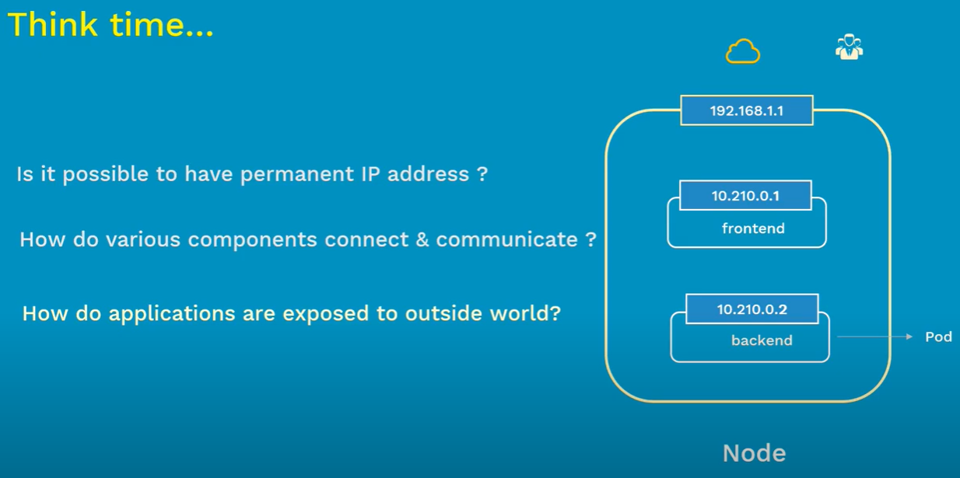

* Services are like group of PODs in a cluster.
* Services are cheap. We can have as many services as possible inside cluster.
* Service comes with load balancing, service discovery etc.
* We use labels to add the services to PODs. If we add the selectors of frontend pod in service. It will group all the frontend pods.

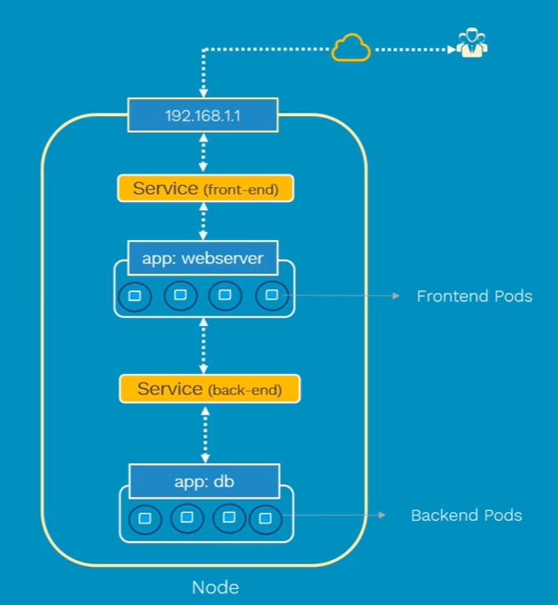

**Types of services:**

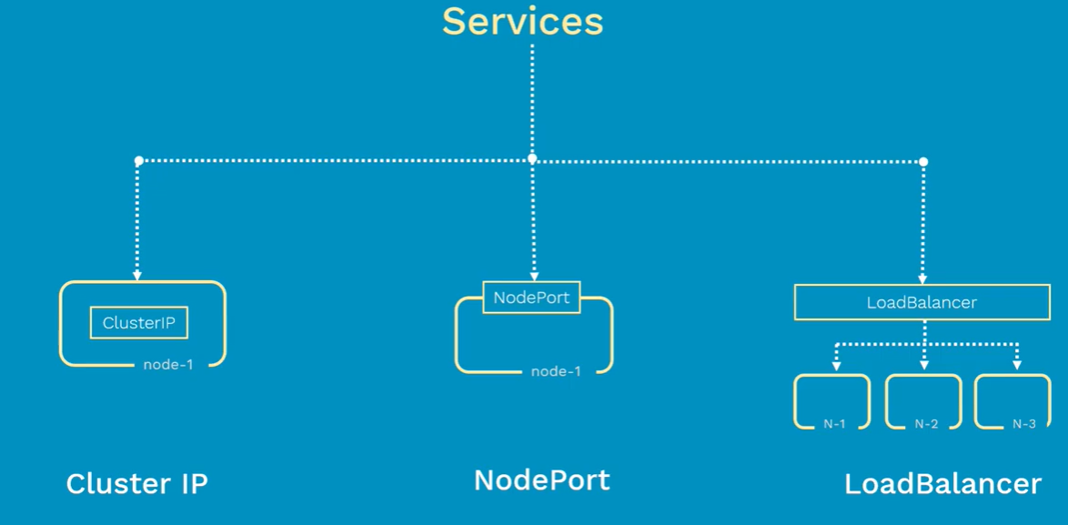

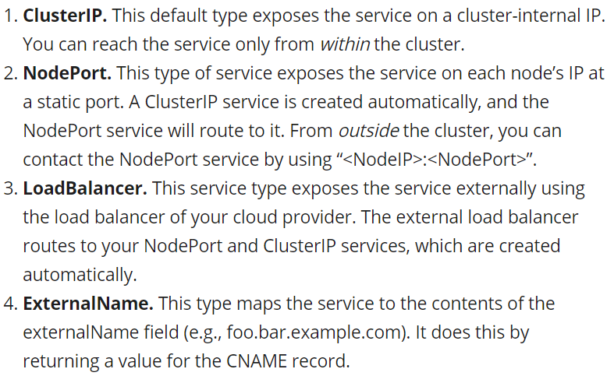

* Cluster IP is reachable only within the cluster. It will be useful when we want to connect frontend POD to the backend POD.
* NodePort is useful when we want to expose the any service to the outside world.
* When we have backend, pods are deployed in multiple nodes. That time we can use load balancer for this